**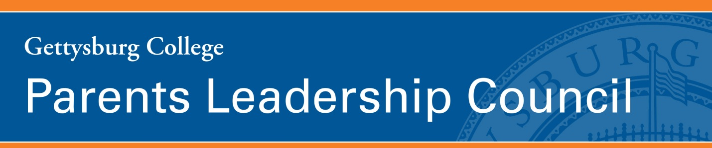  
  
Fall Meeting  
October 31—November 1, 2019**

**Meeting objectives:**

* Affirm PLC’s purpose and areas of focus
* Meet President Iuliano
* Increase our knowledge as ambassadors by learning about and discussing
  + connectGettysburg
  + an interactive tool that maps majors to career fields
* Experience some of what’s new and/or special at Gettysburg College

**Thursday, October 31**

7:00 – 8:30 p.m. **Parents Leadership Council Fall Reception**   
*Chamberlin Room, Fourjay Welcome Center*

**Friday, November 1**

7:45 a.m. **Continental Breakfast***CUB 260*

8:00 a.m. Career Engagement Discussion and Exchange (All are invited)   
*CUB 208 (located in the new addition)*   
The purpose of this session is to showcase highlights of last May’s Career Immersion trip, hosted by Rob Goodwin and Paul Ivans; to spotlight important Career Engagement offerings to you as ambassadors and as Career Engagement volunteers; and to brainstorm ways to get more parents involved.

8:30 a.m. **Continental Breakfast***CUB 260*Feel free to relax in CUB 260 or to stroll around the CUB.

9:00 a.m. **Welcome** (Official start for all PLC members)  
**Introduction of Executive Committee**  
**Introductions of all members***CUB 260*

9:30 a.m. **President Bob Iuliano***CUB 260*

10:15 a.m. **connectGettysburg: The Online Platform of the Gettysburg Network***CUB 260**Stina Niemann, Entrepreneurship and Career Mentoring Coordinator*We will explore the newly implemented online engagement, networking, and mentoring platform of the Gettysburg Network, including its background, goals, and functionalities. Gettysburg encourages alumni, parents, and friends of the College to connect with each other and raise their hand to help students and young alumni in their career journeys. The introduction of the product will be followed by a discussion on parent engagement and general feedback and suggestions.

11:00 a.m. **Move to Atrium Dining**

11:15 a.m. **Visually Matching Majors to Outcomes***Atrium Dining  
Gavin Foster, Ph.D., Associate Vice President of Information Technology   
John Whitehouse, Data Architect*We will give feedback on a new interactive data visualization tool that maps Gettysburg College majors to the career fields in which College alumni are working. We will be asked to provide our thoughts about this new tool that will be viewed by prospective families.

12:15 p.m. **Lunch***Atrium Dining*

12:45 p.m. **PLC Business***Atrium Dining*

* Trustees Report – *Joe Shalleck*
* Development Advisors – *Martha Swartz and Billy Ferrell*
* Career Engagement – *Greg Edelson and Marc Goldman*
* Admissions – *Laurie and Kevin Lippincott* *and* *Mary Smith*

1:30 p.m. **Hidden Gems Tour**Following PLC tradition, we have the opportunity to visit areas of campus that may be new to us and to experience firsthand some of the learning that happens at Gettysburg College. We will divide into groups and travel to the Innovation and Creativity Lab and to the Quantum Optics Laboratory. Read on!

**Quantum Optics Laboratory**The long-standing debate about whether light travels as particles (Newton) or waves (Young) seemed to be settled by theory and experiment in the late 19th century in favor of waves. Then quantum physics in the early 20th century, which revolutionized so much of physics, gave a more problematic answer: light behaves as either a particle or a wave or both depending on the measurement situation. Students get to verify the usefulness and “truth” of often counter-intuitive quantum ideas, such as superposition and entanglement, through single-photon experiments in our Quantum Optics Laboratory.

**Innovation and Creativity Lab**Here some of us will have the chance to don VR goggles, and we will see 3d printers, laser cutters, and CNC machines in action, as well as learn how students are using them to create new and unique objects.

3:00 p.m. **Meeting ends**

**Dates to Note**

**Future PLC Meetings**

* **Spring 2020 PLC Meeting**April 17-18
* **Fall 2020 PLC Meeting/Family Weekend**October 22-23, PLC Meeting  
  October 23-25, Family Weekend
* **Spring 2021 PLC Meeting**April 16-17